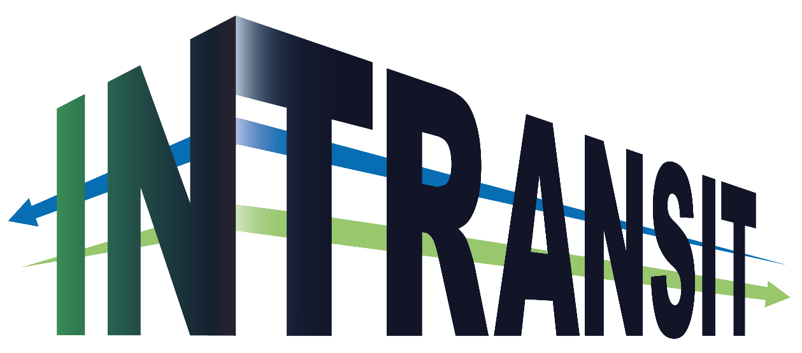

STRENGTHENING THE RESILIENCE OF TEXTILE, AEROSPACE, AND CONSTRUCTION SMES TO TRANSITION TOWARDS GREENER AND MORE DIGITAL SECTORS WITH SOCIAL AND BUSINESS INNOVATION

Frequently Asked Questions

Lead partner: 
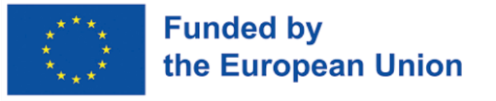
Funded by the European Union. Views and opinions expressed are however those of the author(s) only and do not necessarily reflect those of the European Union or European Health and Digital Executive Agency (HADEA). Neither the European Union nor the granting authority can be held responsible for them.

Project acronym: | InTransit
Project full title: | Strengthening the resilience of textile, aerospace, and construction SMEs to transition towards greener and more digital sectors with social and business innovation
Grant agreement no.: | 101091494
Author(s): | CTA
Reviewer(s): | ATEVAL, AEI Téxtil
Nature: | Report
Dissemination level: | PUBLIC
Total number of pages: | 5
Version: | 1
Publication date: | 07/02/2024

IN TRANSIT has received funding from the Horizon Europe research and innovation programme under grant agreement no. 101091494

DISCLAIMER:
Funded by the European Union. Views and opinions expressed are however those of the author(s) only and do not necessarily reflect those of the European Union or European Health and Digital Executive Agency (HADEA). Neither the European Union nor the granting authority can be held responsible for them.

© 2022-2025 InTransit Consortium Partners. All rights reserved. All trademarks and other rights on third party products mentioned in this document are acknowledged and owned by the respective holders.

Q1 Who can app

Q1 Who can apply?

A1 SMEs (including start-ups) active in the Textile, Aerospace, Construction & Advanced manufacturing key industries, that are established or with a branch office in one of the 27 EU member states.

Q2 What company defined as SME?

A2 The category of micro, small and medium-sized enterprises (SMEs) is made up of enterprises which employ fewer than 250 persons and which have an annual turnover not exceeding EUR 50 million, and/or an annual balance sheet total not exceeding EUR 43 million.

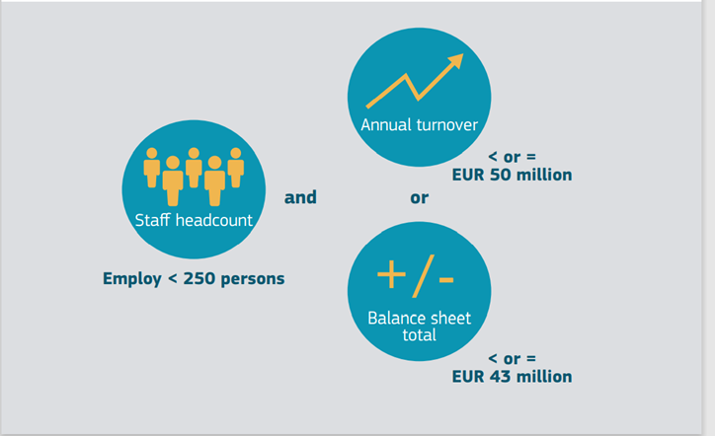

Q3 In cases of partner or linked companies is a SME eligible?

A3 Applicants must be compliant with the definition of micro, small and medium sized enterprises. Large companies cannot apply. For clarifications, please consult the guide of the SME definition via this link.

Q4 Can a SME apply for several vouchers?

A4 Each interested SME can apply individually or in consortia to the voucher in accordance with its needs, but each SMEs may submit only one proposal (not, for example, an individual proposal and a consortium proposal), and only ask for the maximum financial contribution cumulatively. The maximum amount to be granted per SME by INTRANSIT project shall not exceed €50.000,00 in total.

Q5 Can large companies join?

A5 The €49.000 lump sum contributions to SMEs includes the costs of any specialized subcontractor. Subcontractors can typically be innovation actors such as Research Technology Organization (RTO), Universities, Research Institutes, living labs and similar, but could be also public research centre or other, large companies, other specialized SMEs and similar.

Q6 Is there a limitation in the number of other innovation actors participating in an application? Is there a specific limitation of the subcontractor’s budget?

A6 There is no specific limitation. However, subcontracting may cover only a limited part of the action and the beneficiary must properly justify it.

Q7 Can Universities receive funding via the INTRANSIT project?

A7 IN TRANSIT project only grants SMEs. SMEs are allowed to use the grant they receive to subcontract others, like universities.

Q8 Is a Start-up eligible to apply?

A8 SMEs (including start-ups) active in the Textile, Aerospace, Construction & Advanced manufacturing sectors, that are established or with a branch office in one of the 27 EU member states.

Q9 What types of vouchers are offered?

A9 1 type of voucher: DEVELOP. This instrument will provide Cascade Funding support for development projects, including coaching services for developing innovative and sustainable business models. Support will focus on developing innovative processes or new products prototypes and their market testing facilitated by the integration of technological and non-technological innovations methodologies for speeding up market match.

Q10 Is it mandatory to have partners involved from different countries or sectors?

A10 No, it is not mandatory. Yet IN TRANSIT is strongly looking to establish cross-sectoral and/or cross-regional partnerships for new circular business models and, therefore, it is positively evaluating applications with such consortia (SMEs from different countries and from textile/aerospace/advanced manufacturing/ construction sectors).

Q11 Can project expenses be incurred before the project starting date?

A11 Only costs generated during the lifetime of the project can be eligible. Period of costs’ eligibility is from the Contract signature date until the end of the project. So, project expenses cannot be incurred before the official project starting date.

Q12 Can project expenses be incurred after the project end date?

A12 No. Only costs generated during the lifetime of the project can be eligible. Period of costs’ eligibility is from the Contract signature date until the end of the project. So, project expenses cannot be incurred before the official project starting date.

Q13 Which type(s) of staff costs are eligible?

A13 Please refer to the respective section of the Model Grant Agreement for Horizon Europe funded projects (page 36 and followings aga_en.pdf (europa.eu))

Q14 Are the vouchers cover also the VAT costs attached to the services the SME receives?

A14 No, the voucher does not cover VAT.

Q15 Is it possible a SME to apply for more than one project?

A15 Each SMEs may submit only one proposal.

Q16 What is a lump sum?

A16 A lump sum is a fixed amount of money which can be used by beneficiaries for several purposes related to the achievement of the project objectives. However, it is necessary to provide an explanation in the application on how the lump sum will be used including a clear budget proposal (personnel, subcontracting, travels, equipment and consumables). The use of the project budget will be controlled considering the technical advancements by the technical reviewers. The final technical evaluation will assess the coherence of the spent money with the achieved results.

Q17 Is equipment an eligible cost category?

A17. Yes, it is, but only depreciation costs for equipment that is relevant for the success of the project and only for the real time used in the project lifetime.

Q18 Payments by the INTRANSIT project will be made to the applicant SME?

A18 Payments will be made to each SME of the consortium based on their share of the estimated budget in the project Contract.

Q19 Financial capacity documents should be attached with the application?

A19 Each SME either applying alone or as a member of a consortium must be in alignment with situations described in the Call. Selected SMEs should be able to provide some basic information of their financial standing.

Q20 What is the expected final targeted TRL of the project?
A20. No TRL is expected by the end of the project

Q21 How many hours of coaching and who receives them in SCALE-UP?

A21 The coaching support consists of 50h per proposal, no per SME.

Q22 Who gets an extra bonus?

A22 SMEs that have successfully participated in INNOVATE will receive an additional bonus of 7.5% (15% if two of the SMEs involved in the proposal (preparing the proposal in consortia) have successfully participated in INNOVATE).

Q23 Are there any preferences for choosing consortia rather than individual projects?

A23. Each SME can apply individually or in consortia. All proposals will be evaluated against the quality of actions and the proposal. There are no extra points for consortia (only case is if both companies benefited from INNOVATE voucher).

Q24 If an SME has not been selected as beneficiary of the first DEVELOP open call, can it apply again in the second one? If so, and the SME had participated in the INNOVATE call, does it have to participate again in the INNOVATE call to get the 7.5% bonus?

A24. Yes, the SME can be eligible to participate in the 2nd call if it has not been selected in the first one. Regarding the bonus, it should not linked to specific call of INNOVATE, but only to the program itself and it should in principle be maintained.
The 2nd call has not drafted yet, so this matter will be clarified at the later stage.

Q25 If a consortium of two SMEs submits the proposal of the project to be benefited with 98k EUR, the lump sum should be divided 50/50?

A25. The funding is up to 98k€. If the SME requests for the maximum it would be split 50/50. In transit cannot pay more than 49k€ per SME in this call (given the case you have not been benefited from travel vouchers).

Q26 What does it mean to provide cross sectorial aspects? Should the consortium be cross sectoral or the impact the project?

A26. As cross-sectoral aspects are defined in broad terms, it can mean both. The better the case SMEs presents in terms of impact, the higher the points will be.

Q27 When the second open of DEVELOP should be open?

A27. The second call is open and it will close the 16th January 2025.

Q28 If a SME is not selected in the first Develop call, could it apply in the second Develop call with the same idea or the project should be of a different focus/target?
A28. If the SME is not selected in the first call, it can re-apply with any idea (same or different).

Q29 Is it possible to remove the indication of the template to submit the proposal?

A29. Yes, it is possible to remove the indication of the template.

Q30 What type of entity can be subcontracted?

A30. Subcontractors can typically be innovation actors such as Research Technology Organization (RTO), Universities, Research Institutes, living labs and similar, but could be also public research centre or other, large companies, other specialized SMEs and similar.

Q31 What is the duration of the projects funded by DEVELOP?

A31. The projects will have a fixed duration of 4 months.

Q32 Is amount granted in Cascade Funding projects counts to the 'minimis rule'?

A32. The cascade funding is not considered in the “minimis” (European funding) rules.

Q33 Is it possible for a DEVELOP 1st Call beneficiary to be involved as a subcontractor in a DEVELOP 2nd Call project?

A33. Yes, it is possible.

